|  |  |
| --- | --- |
| Team ID | PNT2022TMID16931 |
| Project Name | Project – News Tracker Application |
| Maximum Marks | 8 Marks |

**SETTING UP APPLICATION ENVIRONMENT**

**INSTALL IBM CLOUD CLI**

**STEP 1 : Navigate to cloud.ibm.com**

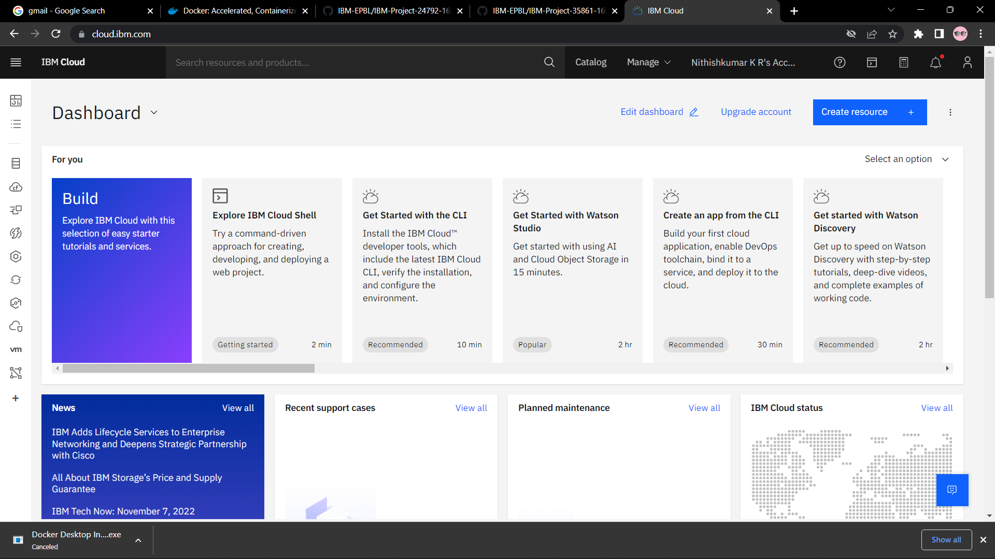

**STEP 2 : Search on container registry and give get started and follow the steps to install IBM CLOUD CLI**

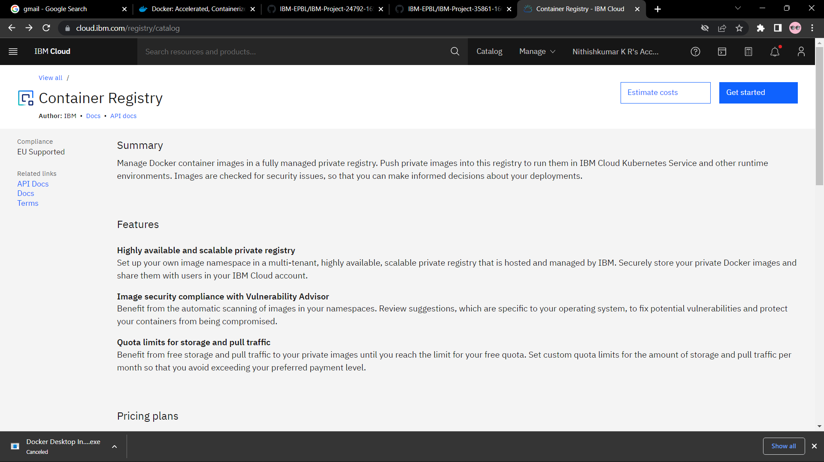

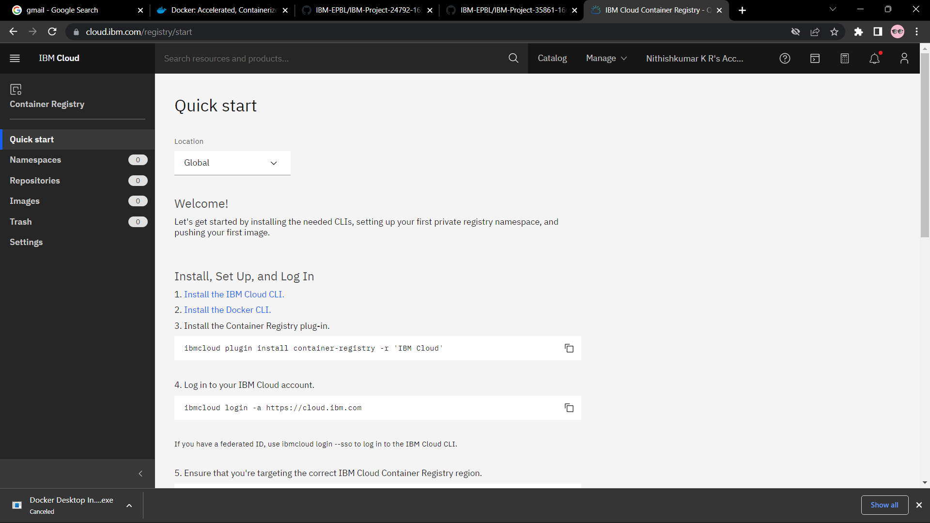

**STEP 3 : Download windows 64 bit installer**

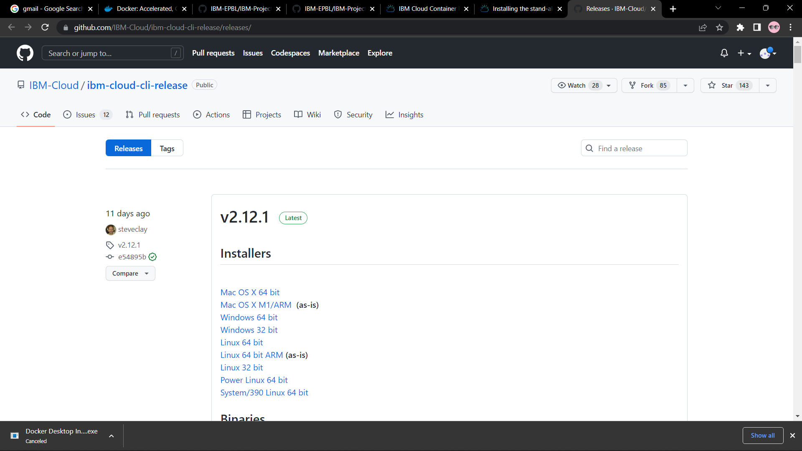

**STEP 4: Open the downloaded .exe file and install it**

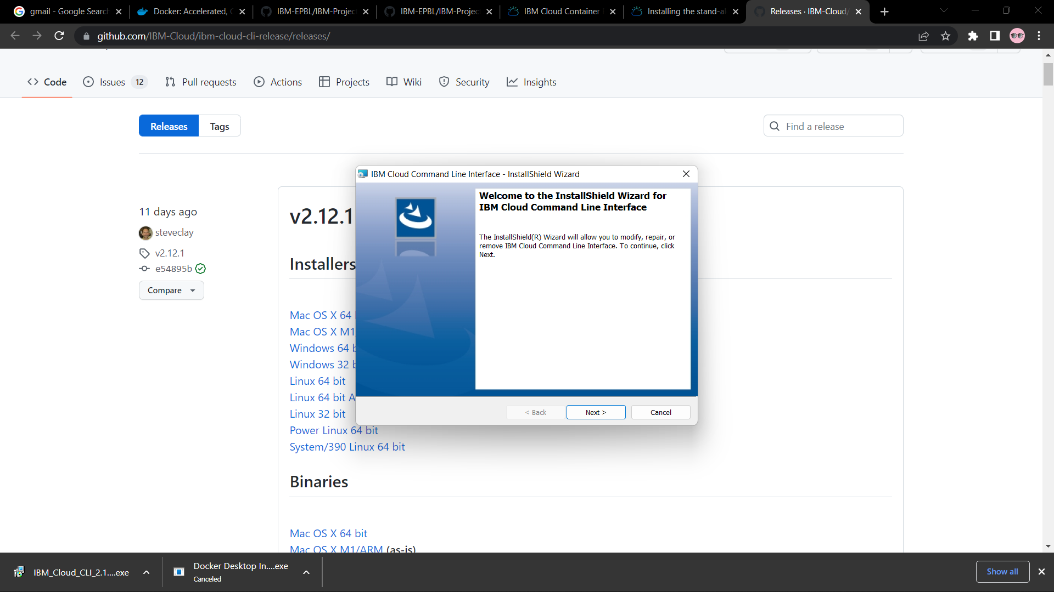

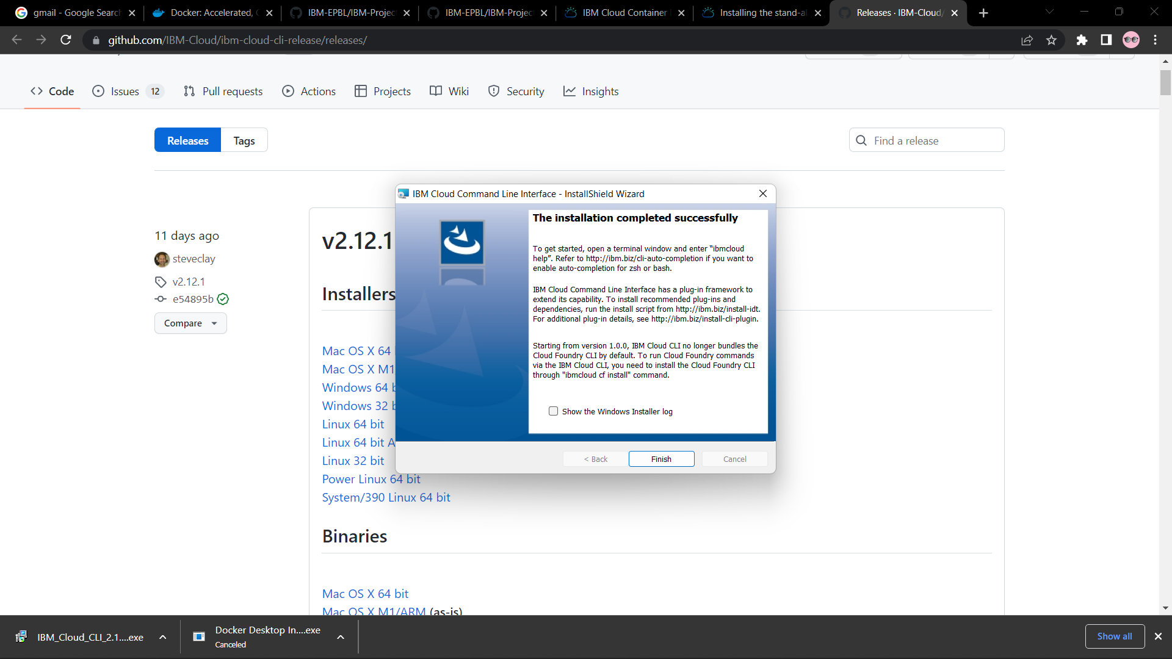

**OUTPUT:**

**IBM cloud CLI is successufully installed.**